

**4th Week Report**

**OJO Members:**

Abdullah Aslam: ***phone:*** *+90 (538) 050 37 64* ***e-mail:*** *ama.abdullah90@gmail.com*

Anar Abdullayev: ***phone:*** *+90 (553) 924 96 43* ***e-mail:*** *abdullayev.1995@gmail.com*

Bulut Ulukapı:  ***phone:*** *+90 (555) 367 26 16*  ***e-mail:*** *ulukapi.bulut@metu.edu.tr*

Syed Saad Saif: ***phone:*** *+90 (546) 781 99 50* ***e-mail:*** *saad.saif@metu.edu.tr*

Umut Can Serçe:***phone*:** *+90 (506) 997 99 88* ***e-mail:*** *serce.umut@metu.edu.tr*

This week we debated on how to proceed with the motor drive system. Even though the four motors are not essential for the project we decided to use them. The reasons behind our decisions are as follows.

The financial advantage to move from four to two motors is minimal. In order to convert the two wheels in the front to freely rotating wheels some equipment such as bearing, holders and shafts are required. When you combine the cost of the required equipment, it can be seen that the cost advantage ranges from 30 liras to nothing depending upon the components chosen. The reason for this is that we were able to get a good” deal on the motors and holders.

Secondly, there are some advantages of using 4-wheel drive system that two-wheel drive does not provide. The four-wheel drive system ensures that uneven surfaces can be easily travelled upon.

This week we also build mechanical holders for our sensors, actuators and the microcontroller. With the help of these new holders, we could attach these parts to our new chassis without losing too much area and space. It also helps us about the accuracy. In the tests we conducted, holders made components more stable.

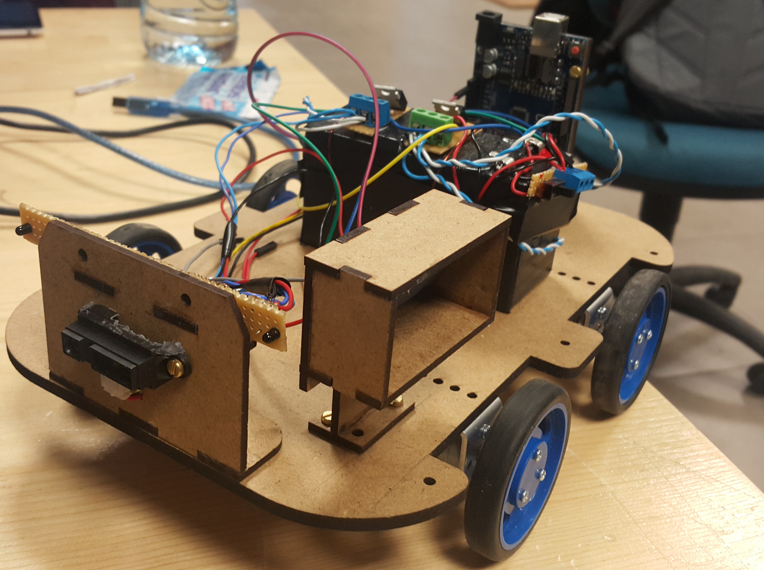

Figure 1: A photo of the robot with new holders